PROFORMA FOR THE APPROVAL PROJECT PROPOSAL

PNR No.: Roll No:

- Name of the Student
Chandan Maurya_________________________________________________________

- Title of the Project
Smart Education ___________________________________________________

- Name of the Guide
Asst.Prof. Rashi Khare_____________________________________________________

- Teaching experience of the Guide ________________________________

- Is this your first submission? Yes

Signature of the Student Signature of the Guide

Date: ………………… Date: ……………………

Signature of the Coordinator

Date: …………………

SHREE L.R. TIWARI DEGREE COLLEGE OF ARTS,
COMMERCE & SCIENCE, MIRA ROAD
(Affiliated to University of Mumbai)
THANE (401107)
MAHARASHTRA
DEPARTMENT OF INFORMATION TECHNOLOGY


CERTIFICATE
This is to certify that the project that the project entitled, "Smart Education”, is Bonafied word of “Chandan Maurya” bearing Seat. No: _________ submitted in partial fulfillment of the requirement for the award of the degree of the BACHELOR OF SCIENCE in INFORMATION TECHNOLOGY from University of Mumbai.

_____________ ____________
Internal Guide Coordinator

_______________________
External Examiner

Date: ______________ College Seal

PLAGARISM REPORT

Abstract

In today’s digital era, effective and interactive learning platforms are essential to enhance the quality of education and bridge the gap between teachers and students. Traditional education systems often lack flexibility, accessibility, and real-time communication, leading to reduced engagement and learning efficiency. This project introduces a Smart Education System that addresses these challenges by providing a unified digital platform for students, teachers, and administrators.
The system enables teachers to upload study materials, notes, and recorded lectures, while students can easily access them anytime, anywhere. It also integrates a chatbot powered by artificial intelligence to assist students in solving academic queries instantly. Real-time notifications keep users informed about new updates, assignments, and announcements. Additionally, the student dashboard allows learners to build simple resumes and receive personalized job suggestions, promoting career readiness.
With a focus on usability, security, and scalability, the platform ensures a seamless experience across devices. By leveraging modern web technologies and cloud-based architecture, the Smart Education System supports real-time interaction, efficient data management, and secure access control. This solution aims to revolutionize traditional education by creating a more connected, automated, and intelligent learning environment

Acknowledgement

I would like to convey my deep appreciation to my Guide Prof. Rashi Khare of IT department for her valuable guidance and encouragement in completion of my project work.
I would also like to express my gratitude to our principal Dr. Sanjay Mishra for providing all the required facilities to accomplish my work.
Finally, I would like to thank my parents and friends, and especially my friend Sunil Gupta for his continuous help, without them this task would not have been completed.

Declaration

I hereby declare that project entitled “Smart Education” done at Shree L.R. Tiwari Degree college, not been in any case duplicated to submit to any other university for the award of any degree. To the best of my knowledge other than me, no one has submitted to any other university. The project is done in partial fulfilment of requirement for the award of degree of Bachelor of Science of (Information Technology) to be submitted as VI th semester project as a part of our curriculum.

Name of Student Name of Student
Chandan Maurya Raj Bind

Index

Chapter 1: Introduction
The rapid advancement of digital technology has fundamentally transformed various sectors, with education being one of the most significantly impacted. In today’s interconnected digital era, the reliance on conventional, purely physical classroom environments is giving way to dynamic, accessible, and interactive digital ecosystems. Effective learning platforms are no longer just supplementary tools; they are essential infrastructures required to enhance the overall quality of education, democratize access to learning resources, and seamlessly bridge the communication gap between educators and learners. This project introduces a comprehensive "Smart Education System," designed to tackle the inherent limitations of traditional educational models by deploying a unified, intelligent, and scalable digital platform.
1.1 Background
Historically, the traditional education system has been characterized by synchronous, location-bound learning. While this model has served its purpose for decades, it often lacks the flexibility and accessibility demanded by modern learners. Students frequently face challenges related to geographic constraints, rigid scheduling, and a lack of personalized, real-time academic support outside of standard institutional hours. Furthermore, communication channels between teachers, students, and administrative bodies are often fragmented, leading to delayed notifications, reduced engagement, and administrative inefficiencies.
The transition to digital learning environments has highlighted the need for centralized systems. However, many existing solutions operate in silos—offering either just video conferencing, solely document sharing, or basic communication, without integrating these features into a single, cohesive ecosystem. There is a pressing need for a platform that not only hosts educational content but also actively assists the student’s learning journey and career preparation. By leveraging modern, component-driven web technologies and robust backend architectures, it is now possible to create highly responsive single-page applications that offer a seamless user experience. This project emerges from the necessity to construct an all-encompassing environment that combines secure data management, real-time interaction, and artificial intelligence to create a truly "smart" educational experience.
1.2 Objectives
The primary goal of this project is to architect and deploy a centralized, web-based Smart Education System. To achieve this overarching goal, the project focuses on the following core objectives:
- To Develop a Unified Digital Ecosystem: Create distinct, secure, and intuitive interfaces (panels) tailored specifically for Administrators, Teachers, and Students, ensuring streamlined operations across the institution.
- To Streamline Academic Resource Management: Enable educators to easily upload, organize, and distribute study materials, comprehensive lecture notes, and recorded video sessions, ensuring 24/7 accessibility for all enrolled students.
- To Integrate Artificial Intelligence for Personalized Support: Implement an AI-powered conversational agent (chatbot) capable of providing instant, context-aware resolutions to academic queries, significantly reducing the dependency on immediate human intervention.
- To Facilitate Real-Time Communication and Collaboration: Incorporate robust video conferencing capabilities and real-time chat functionalities to foster an interactive, classroom-like experience in a virtual setting.
- To Promote Career Readiness: Equip the student dashboard with intelligent tools, including an automated resume builder and personalized job or skill suggestions, to bridge the gap between academic learning and professional employment.
- To Ensure System Scalability and Security: Utilize cloud-based architecture and modern full-stack methodologies to guarantee efficient data management, secure role-based access control, and the ability to scale as user demand increases.
- To Implement Comprehensive Progress Tracking: Provide tools for both educators and learners to monitor academic performance, assignment completions, and overall educational progression.
1.3 Purpose, Scope and Applicability
1.3.1 Purpose
The fundamental purpose of the Smart Education System is to revolutionize the traditional educational paradigm by creating a more connected, automated, and intelligent learning environment. It aims to eliminate the friction associated with physical resource distribution and fragmented communication. By automating routine administrative and academic tasks, the system allows educators to focus more on pedagogy and less on logistics. For students, the purpose is to provide an empowering, self-paced learning environment where educational materials, expert assistance via AI, and career preparation tools are available at their fingertips. Ultimately, the system is designed to maximize learning efficiency, boost student engagement, and prepare learners for the modern workforce.
1.3.2 Scope
The scope of this project encompasses the design, development, and deployment of a full-stack web platform accessible across various devices. The system is structurally divided into three primary modules:
- Administrative Module: Handles the overarching governance of the platform. This includes user authentication and authorization, managing teacher and student credentials, overseeing system security, and maintaining the structural integrity of the educational database.
- Teacher Module: Focuses on content delivery and student monitoring. Educators can seamlessly upload documents, manage multimedia content, schedule and host live video conferencing sessions, issue assignments, and track the progress of their respective classes.
- Student Module: Acts as the primary learning interface. It provides secure access to all uploaded study materials and recorded lectures. Crucially, it houses the AI assistant for instant query resolution, a notification center for real-time updates regarding assignments and institutional announcements, and the integrated resume-building tool to assist with internship and job applications.
The technical scope includes the utilization of modern web frameworks to ensure a highly responsive user interface, the integration of advanced AI models for the chatbot and resume-building features, and the establishment of a secure, cloud-based database for reliable data storage and retrieval.
1.3.3 Applicability
The proposed system is highly versatile and exhibits broad applicability across the educational sector. It is exceptionally well-suited for:
- Higher Education Institutions and Schools: Looking to digitize their curriculum delivery and improve student-teacher communication.
- Private Coaching and Tutoring Centers: Seeking a scalable platform to manage multiple batches, distribute notes, and conduct online doubt-clearing sessions.
- Independent Educators and Creators: Requiring a professional, centralized hub to host their courses, interact with students via video, and provide automated support.
- Distance Learning Programs: Where physical attendance is impossible, and robust, reliable digital infrastructure is the sole medium of education.
1.4 Achievements
Upon the successful implementation and deployment of the Smart Education System, several significant milestones will be realized. The project will achieve the breakdown of geographical and temporal barriers to education, allowing students to engage with their coursework entirely on their own schedules. It will establish a highly efficient, paperless environment for resource distribution, drastically reducing administrative overhead for educational institutions. The integration of the AI chatbot will achieve a significant reduction in response times for student queries, fostering a continuous learning cycle. Furthermore, the inclusion of career-focused tools like the resume builder represents a major achievement in shifting the focus of educational platforms from mere content consumption to tangible career readiness and professional development.
1.5 Organization of Report
To provide a clear, structured understanding of the project's development lifecycle and findings, this report is systematically organized into the following chapters:
- Chapter 1: Introduction – Introduces the project background, primary objectives, scope, applicability, and the overall achievements expected from the proposed system.
- Chapter 2: Survey Technologies – Explores and evaluates the various modern web technologies, AI models, frameworks, and architectural patterns considered for building the platform.
- Chapter 3: Requirement and Analysis – Details the problem definition, specific software and hardware requirements, project scheduling, and the conceptual models underlying the system.
- Chapter 4: System Design – Covers the architectural design, including basic modules, database schema design, data integrity, user interface planning, security considerations, and test case design.
- Chapter 5: Implementation and Testing – Discusses the practical implementation approaches, coding efficiency, and the rigorous testing methodologies (Unit, Integrated, and Beta testing) employed to validate the system.
- Chapter 6: Result and Discussion – Presents the final test reports, comprehensive user documentation, and cost estimation of the finalized platform.
- Chapter 7: Conclusion and Future Work – Summarizes the project's significance, acknowledges its current limitations, and outlines potential future enhancements for the platform.
- Chapter 8: References – Lists the academic papers, official documentation, and technological resources consulted during the research and development lifecycle.

Chapter 2: Survey Technologies
The successful development and deployment of the Smart Education System heavily rely on the selection of an appropriate, modern, and scalable technology stack. This chapter presents a comprehensive survey of the various software frameworks, libraries, database systems, and third-party APIs evaluated and ultimately selected for this project. The architecture follows a modernized MERN (MongoDB, Express.js, React.js, Node.js) stack paradigm, enhanced with cutting-edge artificial intelligence models and real-time communication protocols to fulfill the complex requirements of a unified educational platform.
2.1 Frontend Technologies (Client-Side)
The frontend architecture is designed to be highly responsive, interactive, and accessible across multiple devices. The primary goal is to provide a seamless user experience (UX) for students, teachers, and administrators.
2.1.1 React.js
React.js is an open-source JavaScript library utilized for building complex, component-based user interfaces. It was selected as the core frontend framework due to its Virtual DOM (Document Object Model) feature, which ensures optimal rendering performance by updating only the components that have changed, rather than reloading the entire page. In the context of the Smart Education System, React allows for the creation of reusable UI components—such as video players, document viewers, and chat interfaces—facilitating maintainable code and a consistent design language across the Student, Teacher, and Admin panels.
2.1.2 Vite
To manage the build process and local development environment, Vite was chosen over traditional bundlers like Webpack. Vite leverages native ES modules in the browser to provide extraordinarily fast Hot Module Replacement (HMR). This significantly reduces development time, allowing for instantaneous reflection of code changes. Vite’s optimized build process ensures that the final production assets of the platform are highly compressed and performant.
2.1.3 Tailwind CSS
For styling the application, Tailwind CSS, a utility-first CSS framework, was implemented. Unlike traditional CSS frameworks that provide pre-designed components (which can be rigid), Tailwind provides low-level utility classes that allow for custom designs directly within the HTML/JSX markup. This approach ensures rapid UI development, significantly reduces the size of custom CSS files, and guarantees a fully responsive design that adapts smoothly to mobile, tablet, and desktop screens.
2.1.4 Animation and UI Enhancements
To maximize student engagement and provide a modern feel, several specialized libraries were integrated:
- Framer Motion & GSAP (GreenSock Animation Platform): These powerful animation libraries are used to orchestrate complex, high-performance animations, such as page transitions, interactive hover states on course modules, and dynamic loading sequences. They provide hardware-accelerated animations that do not compromise the application's frame rate.
- Lenis: Integrated to provide a smooth scrolling experience. Standard browser scrolling can often feel abrupt; Lenis implements momentum-based scrolling, making the navigation of long study materials and dashboards feel highly fluid and premium.
- Lucide React: A comprehensive library of clean, scalable vector icons used throughout the platform to enhance visual communication and interface navigation.
2.2 Backend Technologies (Server-Side)
The backend serves as the central nervous system of the platform, handling business logic, data processing, file management, and API integrations.
2.2.1 Node.js and Express.js
Node.js is a cross-platform JavaScript runtime environment that executes code outside a web browser. It uses an event-driven, non-blocking I/O model, making it exceptionally lightweight and efficient for data-intensive real-time applications. Express.js, a minimal and flexible Node.js web application framework, was utilized to build the RESTful API structure. Express simplifies the process of routing HTTP requests, handling middleware, and serving as the intermediary layer between the React frontend and the database.
2.2.2 File Uploads and Storage Management
Educational platforms inherently require robust file handling for assignments, study materials, and multimedia lectures.
- Multer: This Node.js middleware was implemented specifically for handling multipart/form-data. It efficiently processes incoming file uploads (such as PDF notes or student resumes) from the client side, validates the file types, and securely stores them on the server or routes them to a cloud storage bucket.
2.2.3 Asynchronous Communication
- Axios: Employed on both the frontend and backend as a promise-based HTTP client. It is used to make asynchronous requests to external APIs (like the AI services) and to handle data fetching between the React client and the Express server, automatically transforming JSON data and providing robust error-handling mechanisms.
- Nodemailer: A module for Node.js applications to allow easy email sending. It is integrated into the system to handle automated email notifications, such as password resets, new assignment alerts, and administrative announcements.
2.3 Database Management System
Given the diverse and unstructured nature of educational data, a flexible database schema was required.
2.3.1 MongoDB and Mongoose
MongoDB, a leading NoSQL database, was selected to store the application's data. Unlike relational databases that use rigid tables, MongoDB stores data in flexible, JSON-like documents. This is ideal for an education system where a "Course" document might contain deeply nested arrays of "Modules," "Video Links," and "Assignments." To interact with MongoDB efficiently, Mongoose (an Object Data Modeling library) was integrated. Mongoose provides a rigorous schema-based solution to model application data, ensuring data integrity, type casting, and validation before information is permanently saved to the database.
2.4 Security and Authentication Protocols
Ensuring the privacy of student data and the security of administrative controls is paramount.
2.4.1 Google OAuth 2.0 Authentication
To provide a frictionless and highly secure login experience, Google Authentication was integrated as the primary Single Sign-On (SSO) mechanism.
- Frontend (@react-oauth/google): This library allows users to authenticate seamlessly using their existing Google accounts. It handles the complex OAuth 2.0 flow directly within the React interface, retrieving a secure credential token from Google upon successful login.
- Backend (google-auth-library): Once the frontend receives the token, it is transmitted to the Node.js server. The backend uses Google's official authentication library to mathematically verify the token's signature, ensuring it was genuinely issued by Google and has not been tampered with. This eliminates the need for users to remember new passwords and delegates the heavy lifting of password security to Google's robust infrastructure.
2.4.2 JWT and Password Cryptography
For internal session management and traditional email/password logins, additional security layers were implemented:
- JSON Web Tokens (JWT): Used to securely transmit information between the client and server as a JSON object. Once a user is authenticated, the server issues a JWT, which the client includes in the header of subsequent requests to access protected routes (e.g., viewing a secure lecture video).
- Bcrypt.js: A robust password-hashing function utilized to encrypt user passwords before they are stored in the database. It incorporates "salting," which protects against rainbow table attacks, ensuring that even in the event of a database breach, user passwords remain computationally impossible to decipher.
2.5 Real-Time Communication
Traditional web applications rely on HTTP polling, where the client repeatedly asks the server for new data. This is inefficient for a live educational environment.
2.5.1 Socket.io
To enable real-time, bi-directional communication, Socket.io was integrated into both the frontend and backend. Socket.io establishes a persistent WebSocket connection between the user's browser and the server. This technology is the backbone of the platform's live chat features, instantaneous notifications, and live collaborative tools. When a teacher posts a new announcement or a student sends a message in a discussion forum, Socket.io pushes that data immediately to all connected clients without requiring them to refresh the page.
2.6 Artificial Intelligence Integrations
To elevate the platform from a standard learning management system to a "Smart" Education System, state-of-the-art Large Language Models (LLMs) were integrated via API.
2.6.1 Google Generative AI (Gemini) and OpenAI
The system utilizes dual AI integrations (@google/generative-ai and openai) to power its advanced features. These APIs connect the Node.js backend directly to powerful AI models capable of natural language understanding and generation.
- Automated Query Resolution: The AI acts as a virtual teaching assistant. When a student asks a question in the chat interface, the system processes the natural language query, interfaces with the AI models, and returns an accurate, context-aware explanation in real-time.
- Smart Resume Builder: The AI models parse user inputs regarding their skills and academic achievements to automatically generate professional, grammatically correct bullet points and summaries, actively promoting the student's career readiness.
2.7 Summary
The fusion of these technologies forms a robust, modern architecture. React and Vite guarantee a responsive and fluid user interface, while Node.js and MongoDB provide a highly scalable backend capable of managing vast amounts of educational data. The strategic integration of Google Authentication and JWT ensures enterprise-grade security. Finally, the inclusion of Socket.io for real-time interaction and advanced AI models for personalized learning support ensures that the proposed Smart Education System is fully equipped to meet the demands of the modern digital era.

CHAPTER 3: REQUIREMENTS AND ANALYSIS
The requirements engineering and systems analysis phase is arguably the most critical juncture in the Software Development Life Cycle (SDLC). It serves as the definitive bridge between the abstract conceptualization of the Smart Education System and its concrete technical architectural design. This chapter systematically dissects the educational landscape to define the exact problems the proposed system intends to solve. Furthermore, it meticulously details the functional and non-functional requirements, outlines the Agile project schedule, establishes the foundational hardware and software prerequisites, and utilizes standardized conceptual models to visualize the system’s architecture before a single line of code is written.
3.1 Problem Definition
The inception of this project is deeply rooted in the palpable inefficiencies, technological gaps, and pedagogical limitations observed in both traditional physical education models and early-generation digital learning tools. As education scales, standardizing the delivery of knowledge while maintaining personalized student support has become a profound challenge.
Primary Problem Statement: Current educational ecosystems are highly fragmented, lacking a centralized, intelligent infrastructure that can simultaneously handle multimedia content delivery, real-time synchronous communication, and asynchronous AI-driven academic support. This fragmentation leads to reduced student engagement, administrative cognitive overload, and a severe disconnect between academic learning and professional career readiness.
Detailed Sub-Problems:
- Siloed and Fragmented Learning Ecosystems: Currently, educational institutions, independent tutors, and students are forced to navigate a disjointed patchwork of software applications. An institution might use one specialized platform for hosting video conferences, a completely different cloud storage link for sharing PDF notes, and a third-party messaging application for basic communication. This lack of a unified interface creates immense administrative friction for teachers who must duplicate their efforts across platforms, and it causes cognitive overload for students who struggle to locate centralized study materials.
- Delayed Academic Support and the "Feedback Bottleneck": In a standard learning environment, whether physical or basic digital, students frequently encounter conceptual roadblocks when studying independently outside of institutional hours. Because human educators cannot be available 24/7, a "feedback bottleneck" occurs. Students must halt their learning process and wait until the next scheduled class or office hour to resolve their doubts. This disruption in the continuous learning cycle severely diminishes momentum and motivation.
- The Career Readiness and Skill Translation Gap: Traditional Learning Management Systems (LMS) strictly index on curriculum delivery and standardized assessment. They fundamentally fail to bridge the critical gap between acquiring academic knowledge and entering the professional workforce. Students are rarely provided with native, integrated tools that help them translate their newly acquired skills, coursework, and project experiences into professional portfolios or standardized resumes, leaving them underprepared for internship and job applications.
- Inadequate Real-Time Engagement and Isolation: Many existing e-learning portals function merely as static file repositories rather than dynamic digital classrooms. The absence of real-time, bidirectional communication—such as live notifications, instant messaging, and interactive collaborative spaces—fails to simulate the engaging nature of a physical classroom. This digital isolation is a primary contributor to high dropout rates and low completion metrics in online courses.
3.2 Requirements Specification
A rigorous requirements specification acts as the contractual blueprint for the development phase. It defines the exact capabilities the software must possess (Functional Requirements) and the quality standards it must adhere to while performing those capabilities (Non-Functional Requirements).
3.2.1 Functional Requirements
Functional requirements define the core behaviors, automated processes, and business logic integrated into the MERN-stack architecture, categorized by user role:
A. Administrator and Global System Capabilities:
- Centralized Authentication System: The system must allow users to register and authenticate securely utilizing either traditional encrypted email/password combinations or via modern Single Sign-On (SSO) using Google OAuth 2.0.
- Role-Based Access Control (RBAC): The backend Node.js server must strictly enforce access protocols, dynamically routing authenticated users to highly specific Admin, Teacher, or Student dashboards based on their database-assigned roles, ensuring complete data isolation.
- User Lifecycle Management: Administrators must possess a dedicated interface to monitor platform health, verify newly registered educator accounts, and suspend or revoke access for users violating institutional policies.
B. Teacher Module Capabilities:
- Multimedia Course Management: Educators must be provided with an intuitive interface to construct course modules. The system must support the secure upload, processing, and cloud storage of diverse file types (PDFs, PPTs, MP4s) using middleware like Multer.
- Synchronous Virtual Classrooms: Teachers must be able to initiate, schedule, and moderate real-time video conferencing sessions directly within the platform's ecosystem without requiring students to download external desktop clients.
- Instantaneous Broadcasts: Teachers must be able to push critical announcements, assignment deadlines, and syllabus updates that immediately trigger push notifications on the student's dashboard via WebSocket connections.
C. Student Module Capabilities:
- On-Demand Resource Access: The student interface must provide highly organized, 24/7 access to all enrolled course materials, featuring built-in document viewers and media players for frictionless consumption.
- Integrated Generative AI Assistant: The system must feature a persistent chatbot interface. When a student submits a complex academic query, the backend must interface with advanced Large Language Models (Gemini/OpenAI APIs) to process the natural language, contextualize it, and return a highly accurate, formatting-rich educational response in real-time.
- Automated Resume Builder Utility: The dashboard must include a dedicated career-readiness suite. Students will input their educational background, technical skills, and completed platform courses. The system will process this data and programmatically generate a professionally structured, ATS-friendly (Applicant Tracking System) resume available for PDF download.
3.2.2 Non-Functional Requirements
Non-functional requirements dictate the system's operational parameters, security posture, and overall user experience.
- System Performance and Latency: The frontend Single Page Application (SPA), bundled via Vite, must achieve an initial "Time to Interactive" (TTI) of less than 3 seconds on a standard broadband connection. The AI query response time should optimally fall under 4 seconds to maintain conversational fluidity.
- Enterprise-Grade Security: All user passwords must be cryptographically hashed using the bcryptjs algorithm before database insertion. Stateless session management must be maintained using mathematically signed JSON Web Tokens (JWT) transmitted via secure HTTP headers. The system must be protected against common vulnerabilities like Cross-Site Scripting (XSS) and Cross-Site Request Forgery (CSRF).
- High Availability and Reliability: The platform must be architected for a 99.9% uptime. Database queries should be optimized using indexing in MongoDB to prevent timeout errors during peak institutional usage hours (e.g., during assignment submission deadlines).
- Scalability: The Node.js asynchronous, event-driven architecture must be capable of handling hundreds of concurrent WebSocket connections (for live chat and notifications) and heavy I/O operations (file uploads) without choking the main thread.
- Responsive Usability: Utilizing Tailwind CSS, the User Interface must be inherently fluid. It must automatically adapt its layout, typography, and navigation paradigms to provide an uncompromised experience across widescreen desktop monitors, tablets, and mobile smartphones.
3.3 Planning and Scheduling
To manage the inherent complexities of integrating real-time communication and third-party Artificial Intelligence APIs, the development lifecycle strictly adheres to an Agile Software Development methodology. This iterative approach mitigates risk by dividing the project into manageable phases, allowing for continuous testing, immediate stakeholder feedback, and the flexibility to pivot technical strategies if certain APIs deprecate or change.
The project is tracked using comprehensive scheduling models that map out the dependencies between frontend interface construction and backend API routing.
3.3.1 Project Gantt Chart The Gantt Chart below visualizes the chronological timeframe for the entire project. It illustrates the duration of the Requirement Analysis, UI/UX Design, Backend API Development, Frontend React Implementation, AI & Socket Integration, and the final System Testing phases across the project weeks.
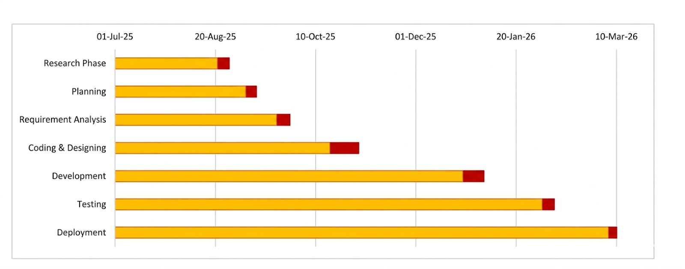
3.3.2 PERT Chart While the Gantt chart shows the timeline, the Program Evaluation and Review Technique (PERT) chart below outlines the sequence of critical tasks. It clearly highlights task dependencies—for instance, demonstrating that the React frontend cannot be meaningfully tested until the Node.js REST API and MongoDB schemas are fully operational. This defines our critical path to deployment.
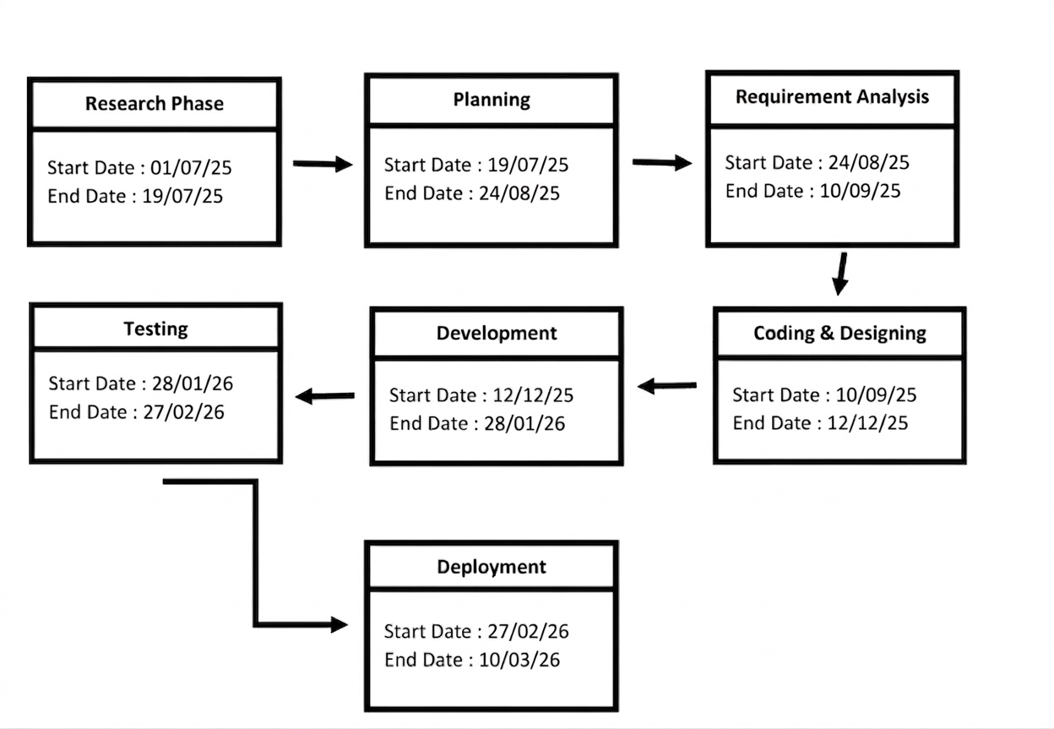
3.4 Software and Hardware Requirements
The development, deployment, and end-user consumption of the Smart Education System necessitate specific technological environments to function optimally.
3.4.1 Hardware Requirements
- Development Server/Machine (Minimum Specifications):
  - Processor: Intel Core i5 (8th Gen or newer) / AMD Ryzen 5 or Apple Silicon equivalent. Required for rapid compilation of modern JavaScript modules.
  - Memory (RAM): 8 GB Minimum (16 GB is highly recommended to run the local Node server, MongoDB instance, React development server, and multiple browser testing instances simultaneously without swapping).
  - Storage: 256 GB Solid State Drive (SSD) for accelerated read/write speeds during heavy npm install operations and database seeding.
- Client Environment (End-User):
  - Processor: Any standard dual-core mobile or desktop processor.
  - Memory: 4 GB RAM.
  - Network: A stable internet connection (minimum 5 Mbps bandwidth recommended for seamless video conferencing and streaming recorded lectures).
3.4.2 Software Requirements
The project embraces a modernized, full-stack JavaScript ecosystem (MERN stack) augmented with specialized libraries.
- Core Programming Languages: JavaScript (ES6+), JSX, HTML5, CSS3.
- Frontend Technologies (Client-Side):
  - Framework: React.js (v18+) for component-driven UI architecture.
  - Build Tool: Vite, for lightning-fast hot module replacement (HMR).
  - Styling: Tailwind CSS for rapid, utility-first responsive design.
  - Routing: React Router DOM for seamless Single Page Application navigation.
  - Animation: Framer Motion and GSAP for fluid, premium user interactions.
- Backend Technologies (Server-Side):
  - Runtime: Node.js (v18 or higher).
  - Framework: Express.js for robust REST API routing and middleware management.
  - File Handling: Multer for parsing multipart/form-data during study material uploads.
- Database Management System:
  - Database: MongoDB (NoSQL) to handle flexible, document-based educational data schemas.
  - ODM: Mongoose to enforce strict schema validation and relationship mapping within Node.js.
- Crucial Third-Party Integrations:
  - Artificial Intelligence: @google/generative-ai and openai Node packages to power the academic chatbot and dynamic resume generation.
  - Real-Time Data: socket.io for bi-directional WebSocket communication (live chat and notifications).
  - Authentication: @react-oauth/google and google-auth-library for secure Single Sign-On.
3.5 Preliminary Product Description
Upon final deployment, the Smart Education System operates as a cohesive, frictionless web application. When a user navigates to the platform's URL, they are greeted by a visually striking, dynamically animated landing page built with Framer Motion, outlining the platform's value proposition. The user initiates entry via a secure Google OAuth popup or standard login portal.
Upon successful cryptographic validation of their credentials, the system evaluates their role. A Student is immediately routed to a personalized, metric-driven dashboard displaying their overall course progress, upcoming assignment deadlines, and recently uploaded materials. The left-hand sidebar provides persistent navigation to their Enrolled Courses, the AI Assistant interface, and the Resume Builder tool. If a student is reviewing a complex PDF on the platform and becomes confused, they can simply toggle the floating AI Chat widget, type their question, and receive an instant, highly-tailored explanation, thereby eliminating the feedback bottleneck.
Conversely, a Teacher logging in is presented with a command-center interface. Here, they can view analytics on student engagement, seamlessly drag-and-drop new video lectures into their course modules, and broadcast system-wide alerts. The entire experience feels native and instantaneous; because the platform is a React-based SPA heavily utilizing asynchronous Axios requests and Socket.io, page reloads are entirely eliminated, resulting in an application that feels as fast and responsive as compiled desktop software.
3.6 Conceptual Models
Before transitioning to the rigorous coding phase, it is imperative to abstract the system’s logic, data structures, and user permissions into standardized visual models. These conceptual models serve as a universal language for developers to verify that all functional requirements have been accounted for architecturally.
3.6.1 System Flowchart The system flowchart delineates the algorithmic pathways and logical decision gates a user traverses. It visually tracks the journey from the initial point of authentication, routing through role-based access checks, and mapping out the specific actions a user can take (e.g., the decision tree of a teacher choosing to upload a file versus starting a live video stream).
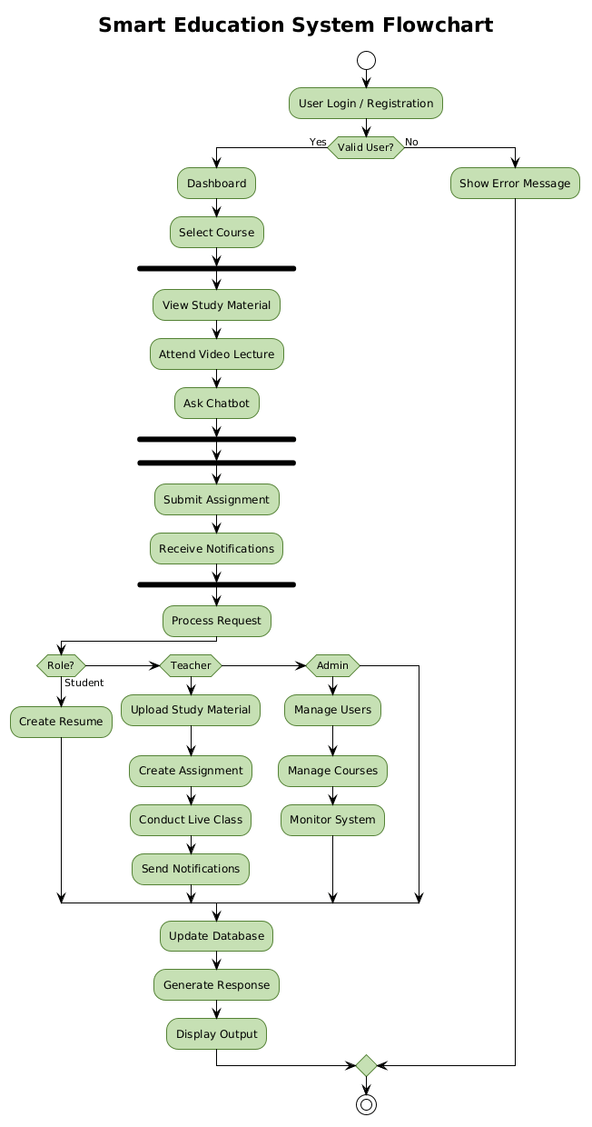
3.6.2 Entity-Relationship (ER) Diagram The Entity-Relationship Diagram maps the backbone of our MongoDB database. While MongoDB is a NoSQL database, relational concepts are still enforced via Mongoose schemas. This diagram highlights the core entities: Users (holding authentication data), Courses (holding curriculum metadata), Materials (holding file URLs and types), and AI_Interactions (storing chat history). It visualizes the critical one-to-many (1:N) relationships, such as one Teacher managing multiple Courses, and one Course containing multiple Materials.
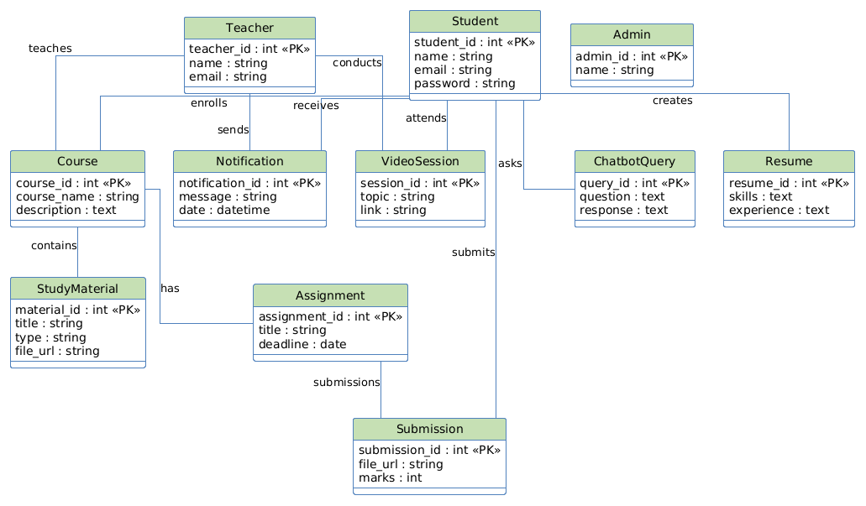
3.6.3 Use Case Diagram The Use Case Diagram defines the behavioral boundaries of the system based on the Unified Modeling Language (UML) standards. It visually represents the primary actors (Student, Teacher, Administrator) as external entities and maps them via interaction lines to specific system functionalities (Use Cases) contained within the system boundary box. This model unequivocally proves that, for example, a Student has authorization to "Generate Resume" and "Query AI", but is strictly restricted from the "Manage Users" or "Upload Course Content" use cases.
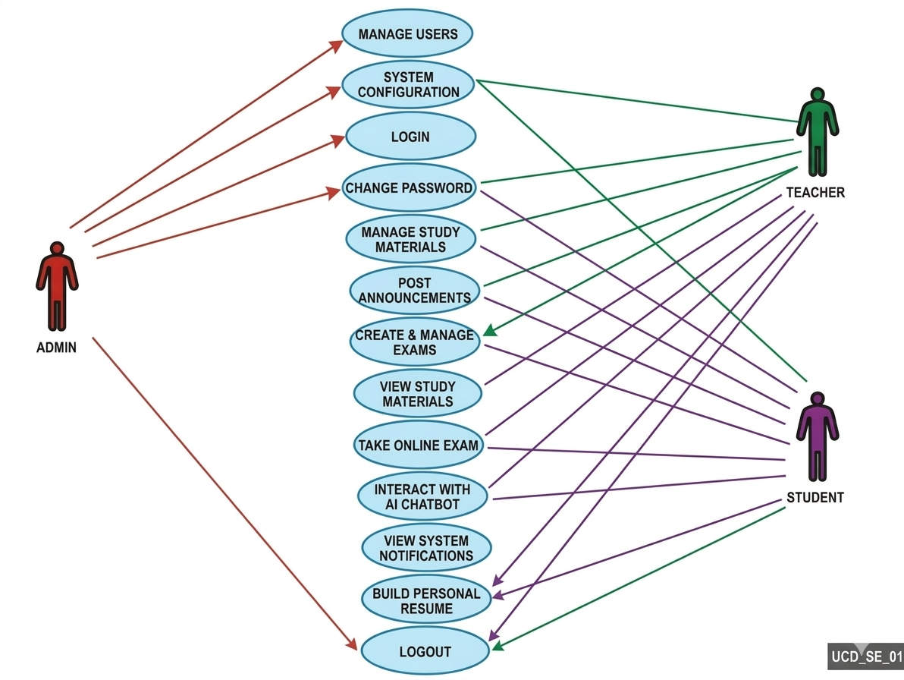
3.6.4 Data Flow Diagrams (DFD) Data Flow Diagrams provide a rigorous visualization of how information enters the system, how it is transformed by internal processes, and where it is ultimately stored.
A. Level 0 DFD (Context Diagram) The Level 0 DFD represents the highest level of abstraction. It treats the entire Smart Education System as a single, centralized process node. It maps the macroscopic data inputs and outputs between the system and external entities, such as the flow of credentials from the User, and the transmission of prompt queries and responses back and forth with the External AI APIs (Gemini/OpenAI).
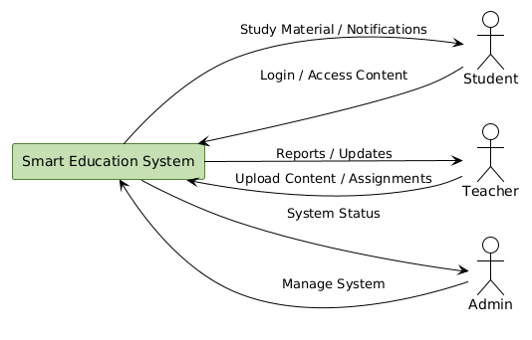
B. Level 1 DFD The Level 1 DFD decomposes the single central process of the Level 0 diagram into its constituent sub-processes. It provides a granular view of data routing, specifically illustrating how data flows through the Authentication module, the Course Content Management module, the WebSocket Real-Time router, and the AI Processing engine. Furthermore, it details exactly which specific database collections (e.g., User DB, Course DB) are queried or updated during each specific sub-process, providing a direct blueprint for backend API development.
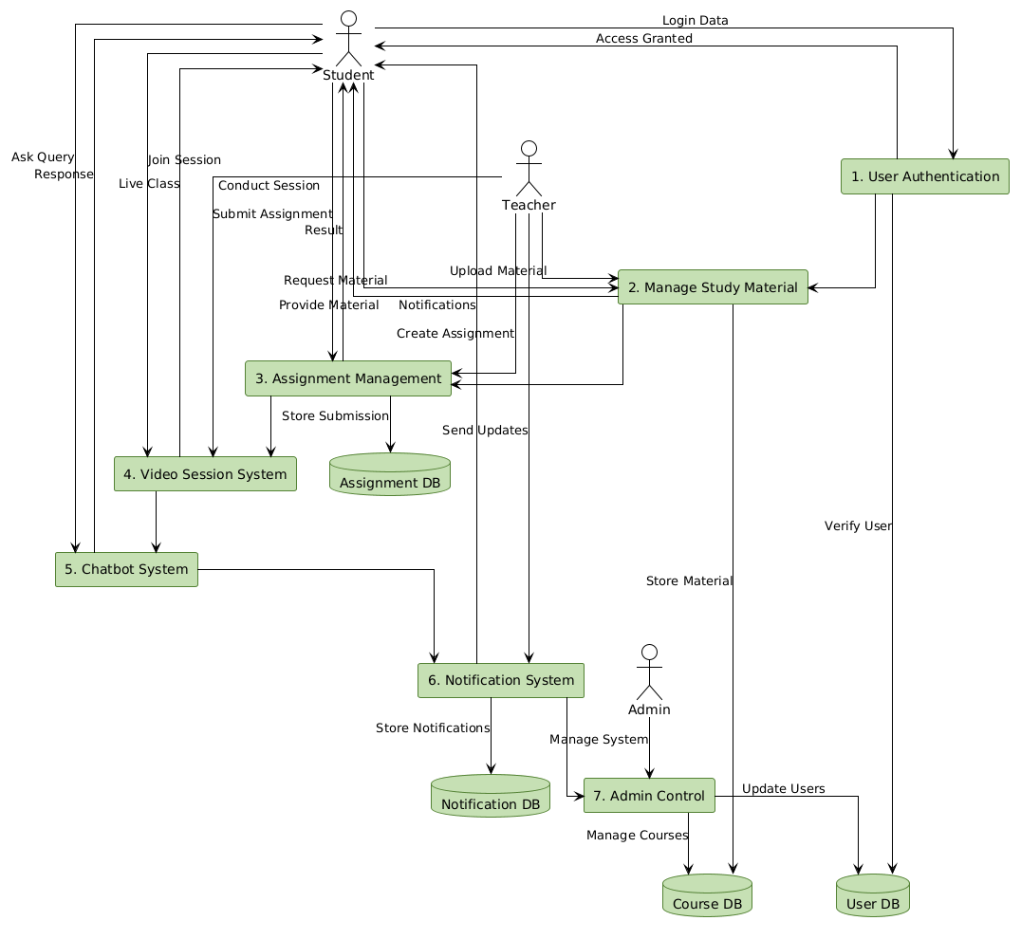

CHAPTER 4: SYSTEM DESIGN
System design is the process of defining the architecture, modules, interfaces, and data for a system to satisfy specified requirements. This chapter transitions the project from a conceptual framework into a concrete technical blueprint. It outlines how the Smart Education System is structurally organized across its frontend React application, its Node.js backend, and its NoSQL database, ensuring that all components interact seamlessly, securely, and efficiently.
4.1 Basic Modules
The Smart Education System is built upon a modular architecture. This separation of concerns ensures that the codebase remains maintainable, scalable, and easy to debug. The system is divided into five core functional modules:
- Authentication & Authorization Module:
This module acts as the secure gateway to the platform. It handles traditional email/password registrations (utilizing bcryptjs for encryption) as well as modern Single Sign-On (SSO) via Google OAuth 2.0. Upon successful login, it generates and issues JSON Web Tokens (JWT) to manage stateless user sessions and strictly enforces Role-Based Access Control (RBAC) to route users to their appropriate interfaces.
- User Dashboard & Management Module:
This module manages the distinct interfaces presented to the users.
  - Admin Panel: Allows system administrators to oversee platform metrics, manage user accounts, and maintain system integrity.
  - Teacher Panel: Provides tools for course creation, student enrollment tracking, and performance monitoring.
  - Student Panel: The centralized hub where learners access courses, view grades, and utilize platform tools.
- Course & Content Delivery Module:
The core academic engine of the platform. It utilizes Express.js and multer middleware to handle the parsing and secure uploading of multipart/form-data (PDFs, PPTs, Video files). It organizes these files hierarchically under specific course IDs and serves them asynchronously to the frontend React components for student consumption.
- Real-Time Interaction Module:
Powered by Socket.io, this module establishes persistent, bidirectional WebSocket connections between the client and the server. It bypasses standard HTTP request-response cycles to enable instantaneous live chat, real-time assignment notifications, and immediate broadcast announcements from teachers to students without requiring page refreshes.
- Artificial Intelligence Integration Module:
This module interfaces with external Large Language Models (LLMs) like Google Gemini or OpenAI. It contains two primary sub-engines:
  - Virtual Assistant Engine: Captures student queries from the chat interface, constructs contextual prompts, queries the LLM API, and parses the returned JSON into readable academic explanations.
  - Resume Generation Engine: Collects structured data (skills, education) from the student dashboard, processes it through the AI for professional formatting, and outputs a downloadable document.
4.2 Data Design
The system utilizes MongoDB, a robust NoSQL database, managed via the Mongoose Object Data Modeling (ODM) library. A NoSQL approach was selected due to the unstructured and hierarchical nature of educational data (e.g., a course containing a highly variable number of modules, videos, and documents).
4.2.1 Schema Design
The database architecture is defined by distinct Mongoose schemas that dictate the structure of the documents stored in MongoDB.
1. User Schema (users)
This schema stores authentication and demographic data for all platform participants.
- _id: Object ID (Auto-generated)
- name: String
- email: String (Unique)
- passwordHash: String (If standard login)
- googleId: String (If OAuth login)
- role: String (Enum: ['Admin', 'Teacher', 'Student'])
- profilePicture: String (URL)
- createdAt: Timestamp
2. Course Schema (courses)
This schema manages the overarching details of a subject or class.
- courseId: Object ID (Auto-generated)
- title: String
- description: String
- instructorId: Object ID (Reference to users schema)
- enrolledStudents: Array of Object IDs (References to users)
- isActive: Boolean
3. Material Schema (materials)
This schema tracks individual pieces of content uploaded to a specific course.
- materialId: Object ID (Auto-generated)
- courseId: Object ID (Reference to courses schema)
- title: String
- fileType: String (Enum: ['PDF', 'Video', 'Document'])
- fileUrl: String (Cloud storage or local path reference)
- uploadedAt: Timestamp
4. AI Interaction Schema (ai_logs)
This schema logs interactions with the AI to maintain context and allow students to review past queries.
- logId: Object ID (Auto-generated)
- studentId: Object ID (Reference to users schema)
- query: String
- aiResponse: String
- timestamp: Timestamp
4.2.2 Data Integrity and Constraints
To prevent database corruption and ensure application stability, strict data integrity constraints are enforced at the Mongoose ODM layer before any data reaches the MongoDB server:
- Entity Integrity: Every document is automatically assigned a unique _id by MongoDB, ensuring no two records are identical. The email field in the User Schema is marked with the unique: true constraint to prevent duplicate account registrations.
- Domain Constraints: Required fields are strictly enforced (e.g., a course cannot be created without a title and instructorId). The role field utilizes an enum constraint, meaning the database will actively reject any registration attempt where the role is not explicitly 'Admin', 'Teacher', or 'Student'.
- Referential Integrity: While MongoDB does not support traditional SQL foreign keys, referential integrity is maintained programmatically using Mongoose's populate() method and .ObjectId references. If a Teacher account is deleted, a pre-remove middleware hook is triggered to cascade the deletion, removing or archiving all courses associated with that specific instructorId to prevent orphaned data.
4.3 User Interface Design
The User Interface (UI) is engineered using React.js and styled with Tailwind CSS to ensure a highly responsive, accessible, and visually modern experience. The design philosophy adheres to a "Component-Driven" architecture, meaning complex interfaces are broken down into reusable building blocks (e.g., a standard 'Course Card' component is reused across the platform).
Key UI Principles Implemented:
- Asynchronous Loading: Utilizing React Suspense and loading skeletons, the UI never freezes during data fetching.
- Responsive Fluidity: CSS Flexbox and CSS Grid (via Tailwind utility classes) ensure the layout adapts seamlessly from 1080p desktop monitors to mobile smartphone screens.
- State Management: React Context API and local state hooks are used to manage UI states (like opening modals or toggling dark mode) without requiring page reloads.
UI Screen Mockups:
(Note: Paste your screenshots or Figma/wireframe designs in the spaces below to visually demonstrate your frontend design).
[PASTE SCREENSHOT/MOCKUP: Landing Page / Login Screen HERE]
Figure 4.1: The primary authentication portal featuring Google OAuth integration.
[PASTE SCREENSHOT/MOCKUP: Student Dashboard HERE]
Figure 4.2: The Student panel displaying enrolled courses, recent materials, and the floating AI Assistant chat widget.
[PASTE SCREENSHOT/MOCKUP: Teacher Dashboard / File Upload Screen HERE]
Figure 4.3: The Teacher panel illustrating the course management and file upload interface.
4.4 Security Issues
Given that the platform handles educational records and intellectual property, security is treated as a foundational requirement rather than an afterthought. The system mitigates multiple threat vectors through the following implementations:
- Authentication & Session Security: The system abandons vulnerable cookie-based sessions in favor of JSON Web Tokens (JWT). Upon login, the server issues a cryptographically signed JWT with a strict expiration time. This token is sent in the HTTP Authorization header for all protected API requests, preventing unauthorized access.
- Password Cryptography: Plain text passwords are never stored. The system utilizes bcryptjs to apply a cryptographic hash and a unique "salt" to every password. This protects the database against rainbow-table and brute-force attacks.
- Cross-Site Scripting (XSS) Prevention: Because React.js automatically escapes string variables in views, the frontend is heavily protected against DOM-based XSS attacks. Furthermore, backend inputs (especially those fed to the AI models) are sanitized to prevent prompt-injection or malicious script execution.
- Cross-Origin Resource Sharing (CORS): The Node.js Express server is strictly configured via the cors middleware to only accept HTTP requests from the specific domain/port where the React frontend is hosted, blocking malicious third-party websites from querying the API.
4.5 Test Case Design
Testing is conducted to verify that the system accurately fulfills its defined requirements and handles edge cases gracefully. The testing strategy encompasses Unit Testing (testing individual functions), Integration Testing (testing how the React frontend interacts with the Node backend), and System Testing (evaluating the complete user flow).
The following table outlines the critical test cases executed to validate the core functionalities of the Smart Education System:
Test Case ID | Module / Feature | Description | Expected Outcome | Actual Outcome | Status
TC-01 | Authentication | User attempts to log in with an unregistered email address. | System denies access and displays "User not found" error message. | System denied access; error displayed. | PASS
TC-02 | Authentication | User clicks "Sign in with Google" and completes the OAuth flow. | User is authenticated, JWT is generated, and user is routed to correct dashboard. | Token generated; user routed successfully. | PASS
TC-03 | Authorization | A user with a 'Student' role attempts to access the /admin-panel URL directly. | The React router intercepts the request and redirects the user to an "Unauthorized" page. | Redirected to unauthorized access page. | PASS
TC-04 | Course Management | Teacher uploads a PDF file (under 10MB) to a specific course module. | File is parsed by Multer, saved securely, and database updates the material list. | File saved; UI updates asynchronously. | PASS
TC-05 | Course Management | Teacher attempts to upload an executable file (.exe) disguised as study material. | Backend validation rejects the file type and throws a "Forbidden File Type" error. | File rejected; error returned to client. | PASS
TC-06 | Real-Time (Sockets) | Teacher posts a new announcement while a student is actively on the dashboard. | Student receives an instant push notification on the UI without refreshing the page. | Notification received instantly via Socket.io. | PASS
TC-07 | AI Assistant | Student submits a valid academic question to the chat interface. | Node.js backend queries the LLM API and returns a formatted text response within 5 seconds. | Formatted response received in 3.2 seconds. | PASS
TC-08 | Resume Builder | Student submits empty skill fields to the Resume Generator. | Frontend form validation halts the process and prompts the user to fill required fields. | Form validation triggered; API call prevented. | PASS

